# MASSIVE TWO-APARTMENT-HOUSE IN UTANGE VIP AREA

I am selling this stunning massive modern house in Utange north coast Mombasa. It’s a two apartment standalone house in a serene and secure area, it stands in a quarter of an acre land with a clean FREE HOLD TITLE.

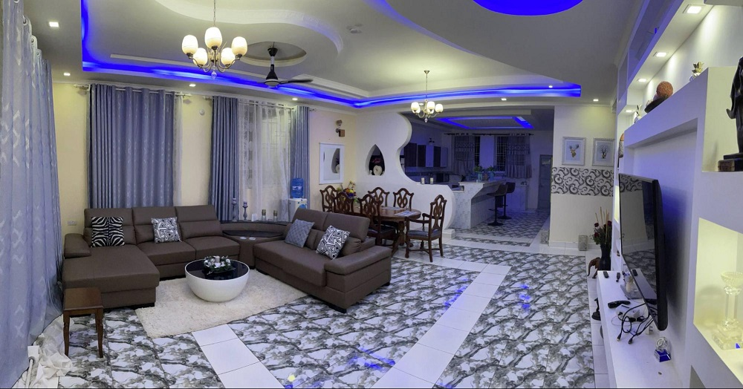

## The House – Two Apartments

This standalone house sits on about 1000 square meter land with a beautiful garden. It houses two separate apartments, one on the ground floor with access to the garden and one with a spacious terrace. Both apartments have a total of approximately 145m² each. Each apartment contains three fully airconditioned bedrooms, a large sitting and dining room and open kitchen. The parking space can be used by up to four cars.

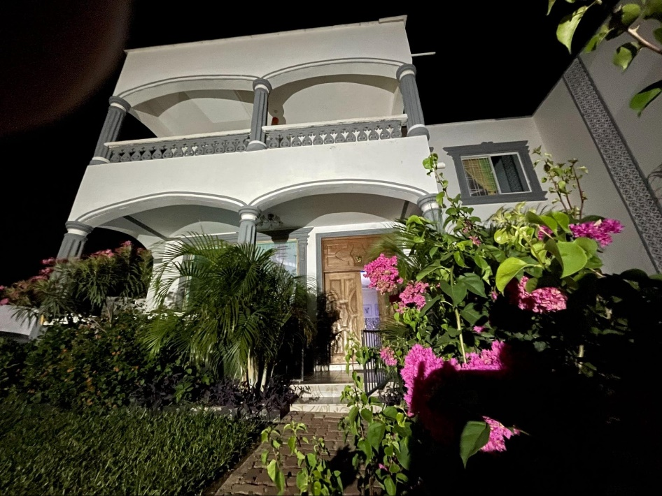

## Apartment 1

The ground floor apartment has direct access to the garden and contains the following features:

* Spacious Living and Dining room with access to the open kitchen.
* Beautiful ceiling with various lightning options
* Direct access to the garden and parking space
* Master bedroom with walk-in closet
* Separate office/study room accessible from the master bedroom
* Two additional bedrooms
* All rooms are equipped with new and modern air-conditions and fan.
* All bedrooms have their own bathrooms
* All rooms newly renovated
* Pantry accessible from the kitchen
* Washing room/guest toilet

## Apartment 2

The apartment 2 on the first floor owns a spacious terrace and nice view into the neighborhood landscape. It contains the following features:

* Spacious Living and Dining room with access to the open kitchen. Air-condition and fan.
* Beautiful ceiling with various lightning options
* Large Terrace
* Master bedroom
* Two additional bedrooms
* All bedrooms have their own bathrooms
* All rooms have modern air conditions plus fan
* All rooms newly renovated

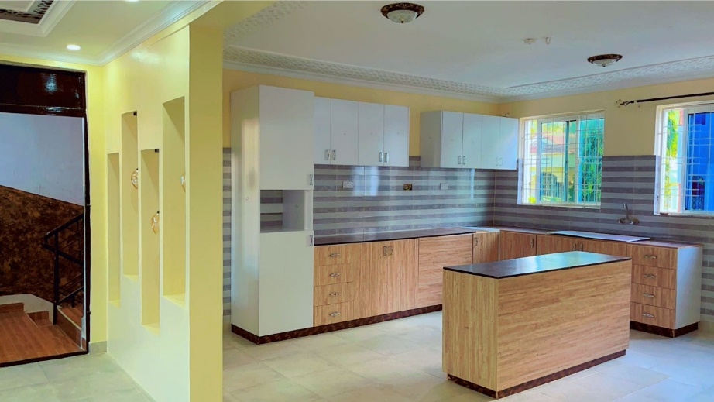

## Additional features

Beside the beautiful garden with large palm and other trees, this compound offers the following additional features:

* Fully fencing wall with electro fence on top
* 4 parking slots
* Servant quarter with two rooms and shower
* Store room
* Dog house
* Fully operational Borehole
* Water tank on rooftop
* Flat rooftop, possible to build a nice rooftop terrace or even another apartment on top
* The garden has enough space to build a swimming pool

## The Neighborhood

The neighborhood is very friendly and developed, the house is built on the higher side of Utange, in that case we don’t have high waters even during strong rains in this part of the area.

* 3rd row from the tarmac road
* 2 minutes’ drive from Bamburi Utange road
* The house is close to Maasai restaurant, Utange Market, Hospital, Schools, Shopping Mall, Gym etc

# The price & Contact

The selling price of this house is 26 Mio Kenyan Shillings (KES)

Inclusion of furniture’s, TVs etc. are negotiable.

If you are interested to see the house, contact the owner:

Brokers may replace with their own contact details:

Joyce Masai

WhatsApp: +254-714 66 53 52

E.Mail: info@radtke-masai.de